Application Form

You are about to participate in the Global Social Venture Competition 2018 by filling in the application form before December 4, 2017. All the information transmitted concerning your project will remain strictly confidential. Be specific and complete as possible by completing the fields below. However, you cannot exceed the limits of the fields.

Thank you, your project is well recorded and will remain strictly confidential.

Provide the following documents
  - An executive summary of 3 pages
  - A summary of interviews held with your stakeholders – 5 pages
  - CV and bio of the key people of the team (associates) (p.7)
- Deliverables must be grouped together in a single Adobe PDF file (preferably) or compatible with Microsoft Word. They must be named according to the following rule: "TeamName_GSVC_FirstTour". The name of the team must appear on each page of each deliverable

Send your files to gsvc@berytech.org

Condition of Participation
Characteristics of projects, projects must be less than 2 years on 31 December 2017 and:

- Responding to a social, societal or environmental need
- Potential for economic viability
- Potential for long-term growth and replicability
- Social or environmental impact

The team must include a student or a graduate from all levels of higher education. Young graduates must meet the following criteria:
- Holders of a degree equivalent to a Bachelor's degree must have been graduated for a maximum of 4 years on 31 December 2017.
- Holders of a Master's or PhD must have graduated for a maximum of 2 years on 31 December 2017.
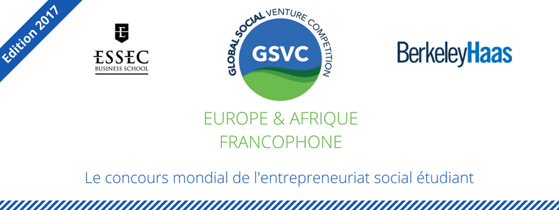

PART 1
Executive Summary
(3 pages)

Instructions (Delete this box before submitting your application)

- For the first round, your executive summary must not exceed 3 pages, in simple lines, with margins of 2 cm and a font of at least 11 points.
- For the second and third rounds, your executive summary must not exceed 5 pages, with the same layout constraints.
- You do not have to answer each question directly - they are supposed to give you a great orientation for each question.
- Ensure that you address at least the following points: value proposition, social impact, business model, team and financial model.
- Deliverables must be grouped together in a single Adobe PDF file (preferably) or compatible with Microsoft Word. They must be named according to the following rule: "TeamName_GSVC_FirstTour". The name of the team must appear on each page of each deliverable
- Visit the "Toolbox" page of www.antropia.essec.fr and the "Resources" page of www.gsvc.org for more tips on writing your executive summary.

Presentation of the Project
Describe your project in a few lines

Value Proposition
- Problem: What problem does your project have? Who are the people who are facing this problem (if relevant)?
- Solution: What product or service does your project offer? How does it address the problem of these people (if relevant)? How is your solution better than what already exists on the market?

Market
Which market is your organization? What is the size of this market? What are its prospects for growth?

Stakeholders
Who are the key stakeholders in your project? How important are they to your business model?

Competitive Adantage
Who are your competitors or other players? What are your competitive advantages? How do you position yourself in relation to these actors?

Economic Model
How will you generate revenue? Who are your clients? What are the growth prospects of your model?
Development/ Marketing Strategy
What is your development strategy (acquisition of partners / clients / beneficiaries)? How do you expect clients and / or beneficiaries to use your goods or services?

Social Impact
How do you intend to achieve your goal? What indicators will you use to measure your social impact?

Team
Who are the members of your team? Why is your team best positioned to respond to your problem? What skills or experiences could your team miss? How do you intend to fill them?

Review of Previous Performance and next steps
What are the most important steps your company has taken so far? What is your next challenge?

Financial Model and projection on 5 years.
What are the main costs of your project? What are your main sources of income? What are the main assumptions of your financial projections (growth rate, market share, customer acquisition cost, etc.)?

Year | 2016 | 2017 | 2018 | 2019 | 2020
Resources
Spending
Profit/Loss

PART 2
Interviews with stakeholders
(10+)
Instructions (Delete this box before submitting your application)

- This summary should not exceed one page, with margins of 2 cm, single spacing and a font of at least 11 points.
- The summary of interviews with stakeholders in the first round should contain one to two citations from interviews with at least 10 existing or potential stakeholders. These stakeholders should include:
  - At least one expert from your sector or a potential partner:
  - At least 2 potential clients / beneficiaries:
- To sum up, please summarize three to five lessons from these interviews (what surprised you, information that emerged, etc.). You will be evaluated on your ability to learn from your interactions with your stakeholders and not on the Point at which the citations confirm your initial assumptions.
- All quotes must be related to the name and status of their issuers and their original organization if this is relevant to you
- Visit the "Toolbox" page of www.antropia.essec.fr and the resources page of www.gsvc.org for more guidance on conducting interviews with stakeholders.
Citations

- Name, Status (Organisation)  [1-2 interview citations] | - Name, Status (Organisation)  [1-2 interview citations]
- Name, Status (Organisation)  [1-2 interview citations] | - Name, Status (Organisation)  [1-2 interview citations]
- Name, Status (Organisation)  [1-2 interview citations] | - Name, Status (Organisation)  [1-2 interview citations]
- Name, Status (Organisation)  [1-2 interview citations] | - Name, Status (Organisation)  [1-2 interview citations]
- Name, Status (Organisation)  [1-2 interview citations] | - Name, Status (Organisation)  [1-2 interview citations]

Lessons

1. [2-3 sentences about this Lesson]

2. [2-3 sentences about this Lesson]

3. [2-3 sentences about this Lesson]

PART 3
The Team

Instructions (Delete this box before submitting your application)

- The CVs of each member of the team must be attached to this file
- This presentation of the team should not exceed one page (single spacing, 2 cm margin, font of at least 11 points). For each member, list their role and write a brief bio that highlights their relevant experiences, skills and expertise. Give the same information to potential advisors and experts who work with you.
- Visit the "Toolbox" page of www.antropia.essec.fr and the resources page of www.gsvc.org for more guidance on conducting interviews with stakeholders.

Management

[Nom, Position]
[Summary of relevant experiences, skills and added value for the team]

[Nom, Position]
[Summary of relevant experiences, skills and added value for the team]

[Nom, Position]
[Summary of relevant experiences, skills and added value for the team]

[Nom, Position]
[Summary of relevant experiences, skills and added value for the team]

POSSIBLE ADVISERS / EXPERTS

[Nom, Position]
[Summary of relevant experiences, skills and added value for the team]

[Nom, Position]
[Summary of relevant experiences, skills and added value for the team]

CV

[Please also attach team CVs]

Follow us on social networks:

For more information, contact us on gsvc@essec.fr

